Half Yearly Progress Report on Research Work carried out from 28.03.2017 to 27.09.2017
Name and address of the candidate : P. Mohandass
Reg. No. P8851
PG and Research Dept. of Chemistry
Saraswathi Narayanan College
Madurai-22.

Occupation if any and address : Associate Professor of Chemistry
Saraswathi Narayanan College
Madurai-22.

Name, designation and address of the : Dr. K. Radhakrishnan
Guide Associate Professor of Chemistry
Saraswathi Narayanan College
Madurai-22.

College where the candidate carried : PG and Research Dept. of Chemistry
out the research Saraswathi Narayanan College
Madurai-22.

Whether the candidate has paid annual
Research fee (mention amount, date of : No
remittance, place of bank, etc.)

Detailed one page report on the progress : Separate sheet Attached
of research work carried out by the
candidate (attach separate sheet)

Remark, if any by the guide : Nil

Signature of the candidate Signature of the research supervisor

Half Yearly Progress Report on Research Work carried out from 28.03.2017 to 27.09.2017
The cyclic voltammograms of (E)-1-(furan-2-yl)-3-phenylprop-2-ene-1-one in acetonitrile containing tetrabutylammonium tetrafluoro borate at various concentration and at constant sweep rate (40 mV s⁻¹) are shown in Fig. (1).The first peak current is proportional to the concentration of (E)-1-(furan-2-yl)-3-phenylprop-2-ene-1-one at constant sweep rate (40 mV s⁻¹) .

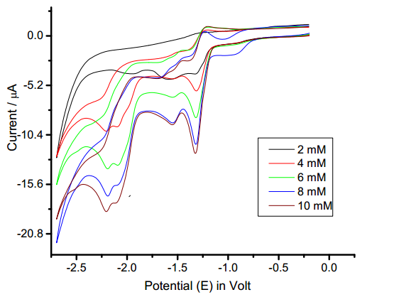
Fig. (1)

Signature of the research supervisor

